How to Add Objectives to your Prosper Test 12/14/07
Author: Lorraine Messina

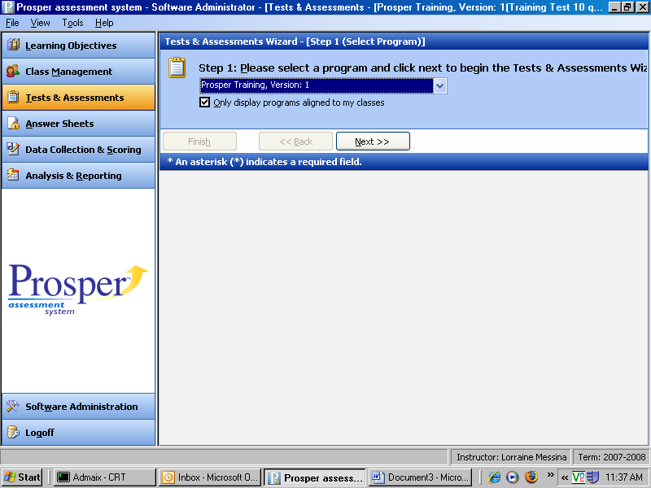

Select the Tests & Assessments Wizard.
Select a program at the top of the screen.
Select Next.

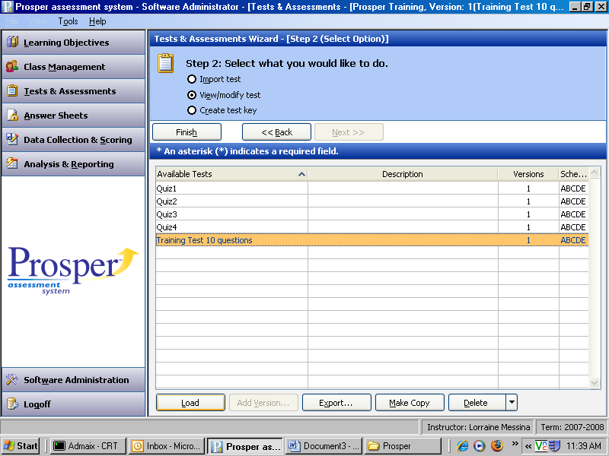

Select a test.

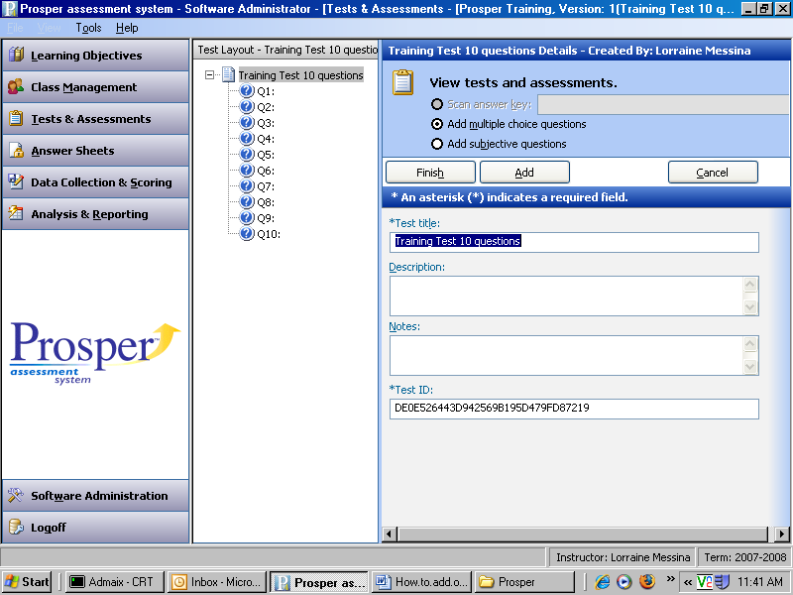

This screen shows your test questions.

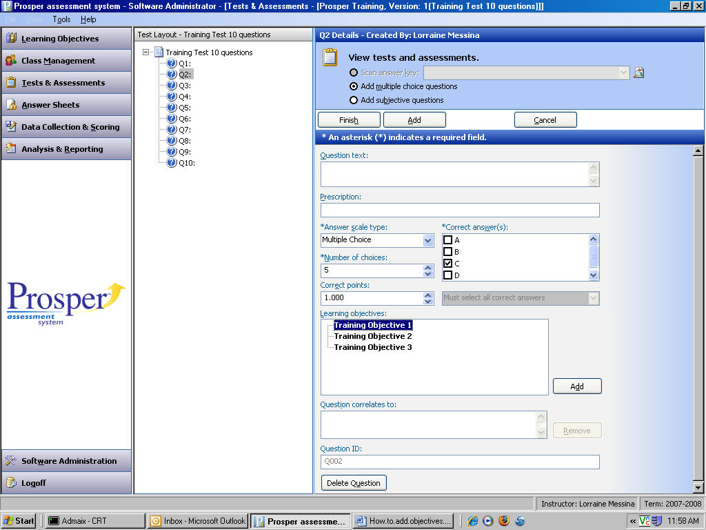

Highlight your test question.
Select a learning objective on the right side of the screen.
Select Add.
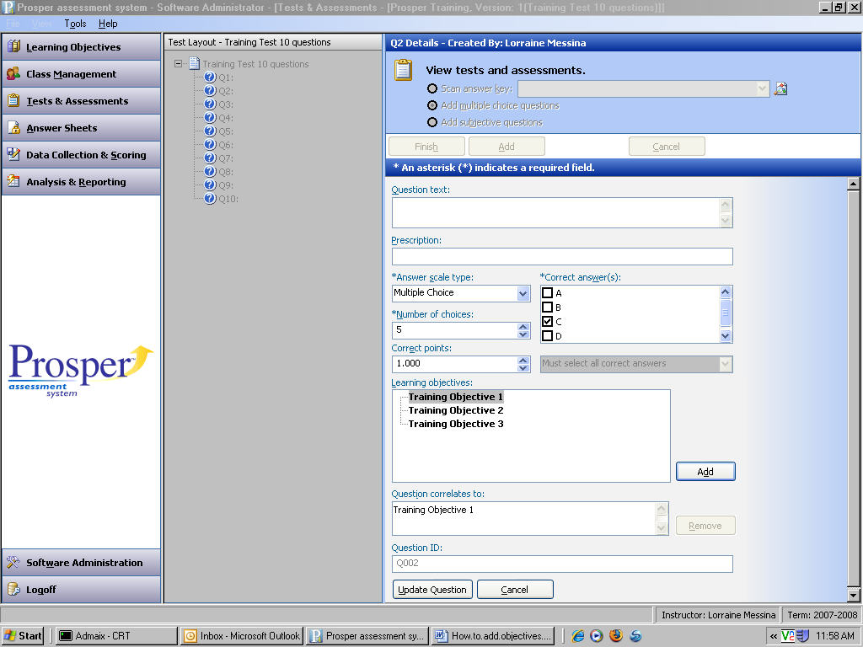

Select Update Question on the right side of the screen at the bottom.
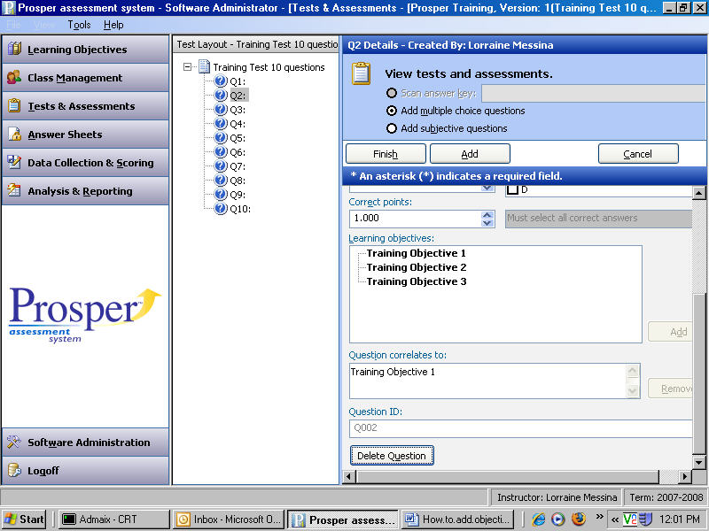

The objective appears in the question box.

